**Lab 02**

**Name: Hassan Shahzad**

**Class: BSCS-7C**

**Registration no: 101454173**

**Task 1**

#include <stdio.h>

#include <stdlib.h>

int main()

{

// A comment, this is so you can read your program later.

// Anything after the // is ignored by C/C++/Java

// Yes, the two slashes are used for comments

// Name: Hassan Shahzad

// Dated; 25th September 2017

printf("I could have code like this.\n"); // and the comment after is ignored

/* Want to use C-style to comment*/

/* You can even write comments

spanning multiple lines

using the C-style */

// You can also use a comma to "disable" or comment out a piece of code:

// printf( "This will run.\n );

printf(" This will run");

return EXIT_SUCCESS;

}

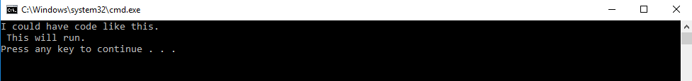

**Task 2**

/********************************************************

* Printing -- program to print out some text. *

* *

* Author: <Hassan Shahzad>. *

********************************************************/

#include <stdlib.h>

#include <stdio.h>

int main()

{

printf("Testing, testing,\n");

printf("one two three.\n\n");

printf("How much output\n\n");

printf("will there be?\n");

return EXIT_SUCCESS;

}

/********************************************************

* Question. *

* How many lines of output are produced (including blank lines)? *

* *

* Answer. *

* <six> *

********************************************************/

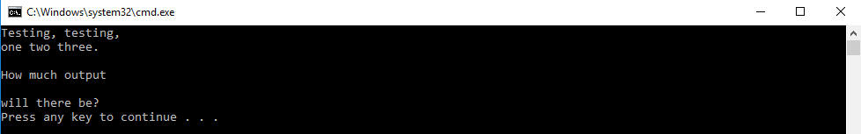

**Task 3**

#include <stdio.h>

#include <stdlib.h>

int main()

{

printf("A \"quoted\" string is\n");

printf(" 'Much' better if you learn\n");

printf("the rules of \"escape sequences\" \n\n");

printf("Also, \"\" represents an empty string. \n");

printf("Don't forget: use \\\" instead of \"!\n");

printf(" '' is not same as\"\n");

return EXIT_SUCCESS;

}

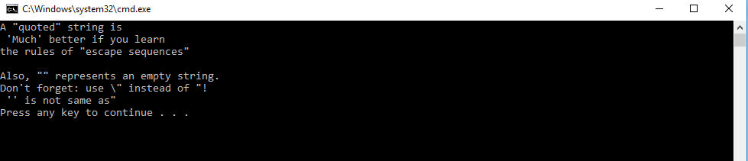

**Task 4**

#include <stdio.h>

#include <stdlib.h>

int main()

{

printf("+--------------------------------------------+\n");

printf("| Pakistan Post ###### |\n");

printf("| Hassan Shahzad ###### |\n");

printf("| NUST-SEECS ###### |\n");

printf("| Islamabad,Pakistan |\n");

printf("| _ _ _ _ _ |\n");

printf("| |_|_|_|_|_| |\n");

printf("| Postal Code |\n");

printf("+--------------------------------------------+\n");

return EXIT_SUCCESS;

}

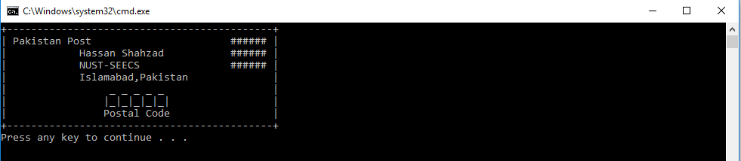

**Task 5**

#include <stdio.h>

#include <stdlib.h>

int main()

{

printf("For the name Hassan Shahzad ...\n\n");

printf(" H H SSSSS\n");

printf(" H H SS\n");

printf(" HHHHHH SSSSS\n");

printf(" H H SS\n");

printf(" H H SSSSS\n");

return EXIT_SUCCESS;

}

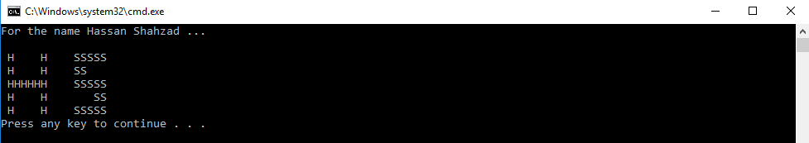

**Task 6**

/********************************************************

* Math -- program to do some math. *

* *

* Author: <your name>. *

********************************************************/

#include <stdlib.h>

#include <stdio.h>

int main()

{

// This will print the statement enclosed within the quotaion marks

printf("I will now count my chickens:\n");

// This will print the answer of 25 + 30 / 6

printf("Hens %f\n", (25.0 + 30.0 / 6.0));

// This will print the answer of 100 - 25 * 3 % 4

printf("Roosters %f\n", (100.0 - 25 * 3 % 4));

// This will print the statement enclosed in the quotation marks

printf("Now I will count the eggs:\n");

// This will give the answer of 3 + 2 + 1 - 5 + 4 % 2 -1 / 4 + 6

printf("%f\n", 3.0 + 2.0 + 1.0 - 5.0 + 4 % 2 - 1.0 / 4.0 + 6.0);

// The enclosed statement is FALSE

printf("Is it true that 3 + 2 < 5 - 7?\n");

// This will check if it is true or false

printf("%s\n", ((3 + 2 < 5 - 7) ? "true" : "false"));

// This will print answer of 3 + 2 and 5 - 7

printf("What is 3 + 2? %f\n", (3.0 + 2.0));

printf("What is 5 - 7? %f\n", (5.0 - 7.0));

// This will the enclosed statement

printf("Oh, that's why it's false.\n");

// It will print the enclosed statement

printf("How about some more.\n");

// prints the starting string as true or false

printf("Is it greater? %s\n", ((5 > -2) ? "true" : "false"));

printf("Is it greater or equal? %s\n", ((5 >= -2) ? "true" : "false"));

printf("Is it less or equal? %s\n", ((5 <= -2) ? "true" : "false"));

return EXIT_SUCCESS;

}

/********************************************************

* Question. *

* Notice the math seems "wrong"? There are no fractions, only whole numbers. *

* Find out why by researching what a "floating point" number is. *

* *

* Answer. *

* <The term floating point refers to the fact that a number's radix point (decimal point, or, more commonly in computers, binary point) can "float"; that is, it can be placed anywhere relative to the significant digits of the number.> *

********************************************************/

